Name_______________________ Student ID ____________________ Date: __________

Duration: 1h 15min, Format: Closed Book

Resources:

* **Labtest2_practice_template**.zip
* Lab sheets 1/2/3/4/5 (Hard copies provided by lab)

**Instructions:**

1. Extract **Labtest2_practice_template**.zip to D:\PXXXXXXX_Your_name
2. You are expected to interface to the Conveyor Kit when answering questions. Strictly refer to the Tag name & hardware address below.
3. Complete the program and save it. Demonstrate to Instructor.
4. Students shall not use Network and Mobile devices during the test.
5. Students shall not remove any papers from the test venue.

Address for Conveyor System

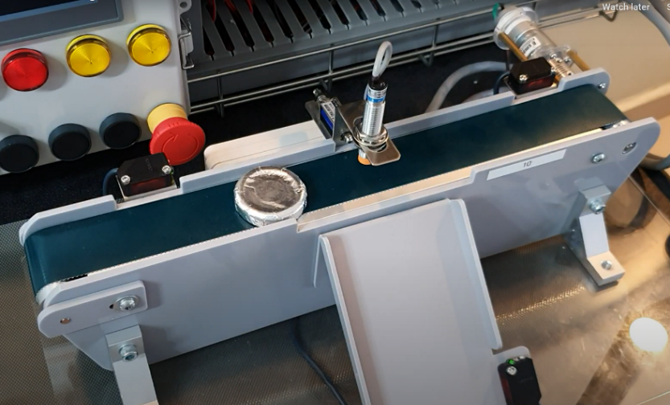

Sensor_Start  
%I127.1

Sensor_End  
%I127.2

Sensor_Inductive  
%I127.3

**Solenoid  
%Q129.2**

Sensor_Slide  
%I127.0

**Motor_FWD %Q129.0  
Motor_REV %Q129.1**

Create the PLC program and link it to the HMI program provided. You are required to add the missing operation_lamp to the HMI.

Create MISSING  
Operation  
Lamp

|  |  |  |  |
| --- | --- | --- | --- |
| **s/n** | **Requirements** |  | **Marks** |
| 1 | Placing workpiece at **sensor_start** should turn its indicator ON(green) (this proves the sensor and HMI works)  Removing the workpiece turns it OFF(grey)  *\*Hint: refer to Lab5 Task 2 to learn how to link indicators and button on screen to PLC program.*  *\*Hint: if you are practicing using simulation instead of lab equipment, sensor_start can be change to %M instead of %I, so you can modify it easily.* | 10 |  |
| 2 | Before operation begins, the **operation_lamp** is red (operation lamp is missing from your HMI, you have to create it) | 10 |  |
| 3 | When workpiece is placed at **sensor_start** & **start_button** is pressed, **operation_lamp** turns green and stays green throughout the process. | 10 |  |
| 4 | **Forward** / **Reverse** arrow indicator turns green whenever the conveyor moves in the respective direction. Otherwise, they are grey. | 5 |  |
| 5 | The sequence is as follows:   * forward for **7 seconds** * stops for **10 second** for painting to take place, **Spray_paint** should be ON(**blue**) during this time. * reverse until workpiece reaches **sensor_start.**   *\*Hint: use timer, refer to Lab2.* | 20 |  |

|  |  |  |  |
| --- | --- | --- | --- |
| 6 | At this instance, the **operation_lamp** will turn back to red. | 5 |  |
| 7 | At the same time, **Remove_painted_part** indicator will blink green at 0.5Hz (i.e 1sec on, 1sec off).  *\*Hint: use blinking bits. Refer to Lab3: Task1* | 10 |  |
| 8 | When a worker collects the painted part by pressing **Acknowledge** button, the indicator above will stop blinking. | 5 |  |
| 9 | The above process can be repeated without problems.  (Marks will be deducted if the process can repeated before the Acknowledge button is pressed in item(7)) | 10 |  |
| 10 | The number_of_painted_parts should be displayed correctly on screen.  *\*Hint: use counter. Refer to Lab3.*  *\*Hint: to display counter on screen, Refer to Lab5: Task4* | 10 |  |
| 11 | The number_of_painted_parts can be reset at any time using the clear button. | 5 |  |